# **Hackathon Use Case: AI-Powered Insurance Fraud Detection System**



**Introduction**

Insurance fraud is a significant challenge in the industry, leading to billions in losses annually. Fraudulent claims are often disguised as legitimate ones, making it crucial to leverage **Artificial Intelligence (AI), Machine Learning (ML), and Natural Language Processing (NLP)** to detect anomalies and improve claim verification.

This hackathon challenges participants to develop an **AI-powered fraud detection system** that automates insurance claim validation, fraud detection, and decision-making using **ML models, NLP for document analysis, and Generative AI for claim summarization and pattern recognition**.

**Problem Statement**

Participants must build a **fraud detection pipeline** that processes **customer insurance claims**, validates them, detects fraudulent patterns, and decides whether a claim should be **approved, flagged for human review, or rejected**. The system should handle structured and unstructured data (claim descriptions, images, and historical fraud cases) to **enhance fraud detection accuracy**.

**Dataset (Synthetic & Realistic)**

* **Structured Data**: Claim details (amount, claim type, history, claim frequency, customer profile, etc.).
* **Unstructured Data**: Claim descriptions, documents, emails, and customer interactions.
* **Historical Fraud Cases**: Labeled fraud and non-fraud claims for training.
* **Images/Documents**: Claim-related receipts, invoices, or medical records.

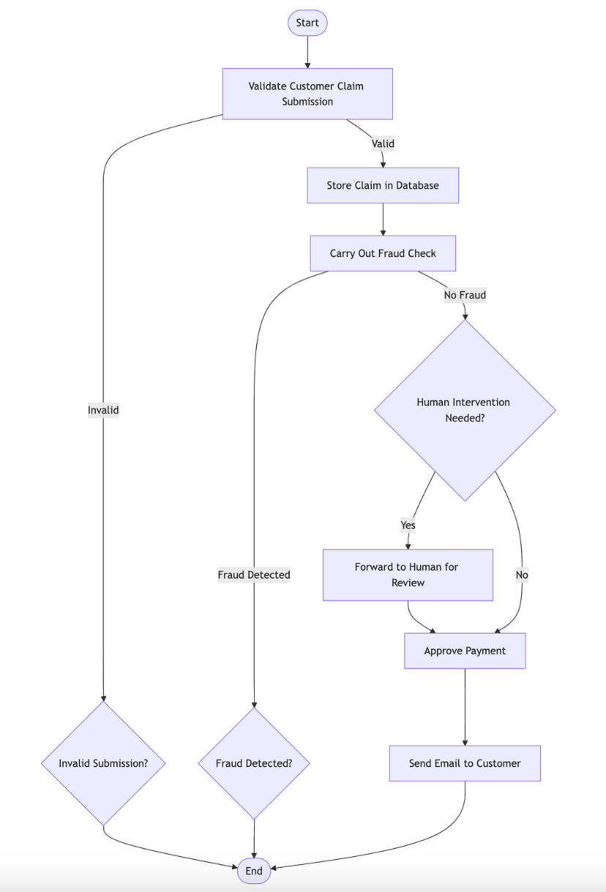

**Use Case Overview:**

The following steps outline the general process involved in the insurance claim submission and fraud detection cycle:

1. **Claim Submission Validation:**
   * Claims are submitted by customers through various platforms.
   * Claims must be validated for authenticity before further processing.
   * Invalid submissions should be rejected, while valid claims move forward.
2. **Fraud Detection Process:**
   * Once the claim is validated, the next step is a fraud detection check.
   * Fraud detection algorithms will analyze the claim for inconsistencies, anomalies, or suspicious patterns.
   * The system should flag any claim with suspected fraudulent activity.
3. **Human Intervention Requirement:**
   * If fraud is not detected but the system suspects irregularities, human intervention will be requested.
   * The claim is forwarded to a human reviewer for a final decision.
4. **Approval & Payment Processing:**
   * If no fraud is detected and no human intervention is required, the claim is approved for payment.
   * An email is sent to the customer to inform them about the approval.

**Hackathon Execution Steps:**

Participants will develop the following components during the hackathon:

**Hackathon Tasks:**

1. **Claim Validation:**
   * Implement an NLP model to validate customer submissions.
   * Parse claim descriptions and extract key data (e.g., claim amount, type of injury, etc.).
2. **Fraud Detection:**
   * Train a fraud detection model using machine learning techniques.
   * Implement anomaly detection based on claim patterns.
3. **Human Intervention Process:**
   * Design a system to forward claims needing human review.
   * Use Generative AI to generate summary reports for human review.
4. **Approval & Email Notification:**
   * Develop an automated approval and payment process.
   * Send an email notification to the customer once the claim is approved.

**Expected Outcome:**

By the end of the hackathon, participants will have developed an intelligent, automated insurance claim fraud detection system. This system will demonstrate the power of NLP, ML, and Generative AI in automating processes, detecting fraud, and assisting human decision-making in the insurance industry.

**Evaluation Criteria:**

1. **Accuracy of Fraud Detection**: How well does the system detect fraudulent claims based on provided datasets?
2. **Efficiency of NLP and Text Analysis**: How effectively does the system validate claims based on textual data and metadata? The system should be able to handle large volumes of unstructured data.
3. **Generative AI Integration**: How well does the system use Generative AI for human intervention or to produce valuable insights?
4. **Real-World Application**: How applicable is the solution to a real-world insurance fraud detection scenario?
5. **System Integration**: How well do the various AI techniques (NLP, ML, Generative AI) integrate to form a cohesive workflow?